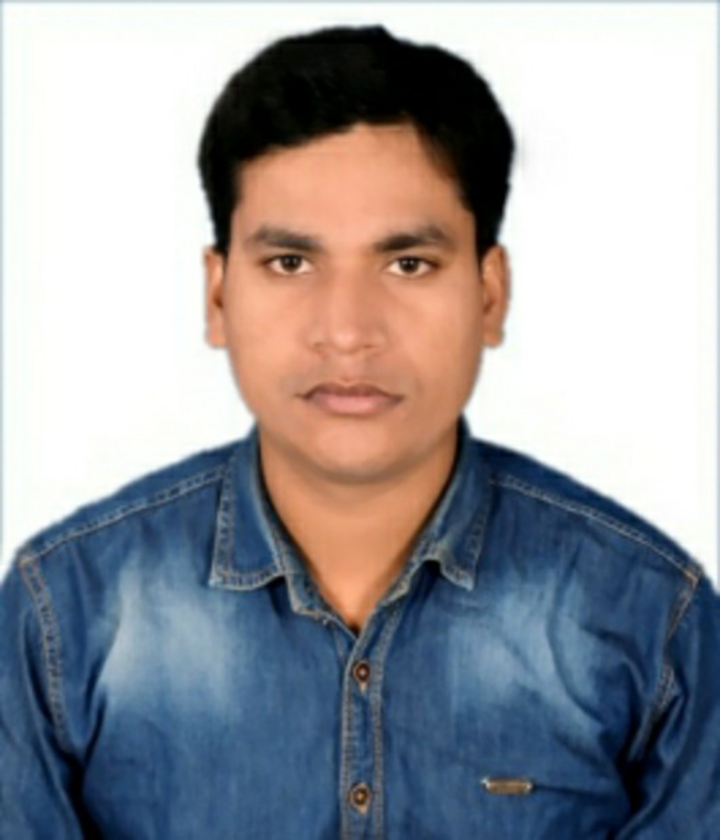
Resume
AGASTYA CHANDRA PANDEY
Gram-Unchdeeh, Post-Parasi dubey,Dist-Sonbhadra, Uttar Pradesh.PIN-231216
Contact: 8639327695,8982537518; E-mail:agastya95pandey@gmail.com
MECHANICAL ENGINEER –CAPTIVE POWER PLANT AND HOT ROLLING MILL
Seeking challenging assignments across the Industry
Objective:

To work with an organization that provides the opportunity of working on challenging projects so as to result in mutual gains in terms of long-term benefits and knowledge.

Job Profile:

- 5.4 years’ experience of Sr. Mechanical Maintenance Engineer in Captive power plant 1x30 mw and (6x150 MW Boiler maintenance).

- Currently working in Thermax Limited O & M at the site of Kalburgi cement Pvt. Ltd. Captive power plant 1x30 MW and WHRB 1x8.5 MW, Gulbarga Karnataka as a Sr. Mechanical Engineer.

Work experience-1
- Aug 2021 to Currently working in Thermax Limited O & M at the site of Kalburgi cement Pvt. Ltd. Captive power plant 1x30 MW and WHRB 1x8.5 MW, Gulbarga Karnataka as a Sr. Mechanical Engineer.
- Running maintenance of power plant and PM
- Coal Handling plant maintenance
- Water treatment Plant Maintenance
- Bearing replacement of rotary parts
- Pressure setting of pumps
- Maintenance of Manual, Motorized & pneumatic valves.
- Maintenance of HP & LP Bypass valves and its oil supply unit.
- CW pump and other pumps preventive maintenance.
- Air pre–Heater Maintenance.
- Maintenance of ESP duct.
- Platform making at the boiler area for the over hauling.
- Refectory work done inside the boiler when the shut down and overhauling.
- Daily equipment health checking.
- Effective field supervision for zero defect maintenance.
- Maintaining PTW and LOTOTO logs as per work planning.
- Maintaining shop floor store inventory.
- Manpower planning.
- Analysis of defects and take remedial action. Avoid job repetition & implement horizontal replication.
- Standardization & improvement in maintenance work method to achieve best maintenance quality.
- Shut Down and Planned maintenance.
- Training and guidance to Technician for maintenance jobs.
- Preparation analysis and distribution of monthly report of planned maintenance.

Work experience-2
- April 2021 to July 2021 working in Hammelmann India at the site of Utkal Alumina International ltd (Aditya Birla Group) as Site Engineer.
- Hydro-jetting work.
- Monitor High pressure Pump working and if required maintenance.
- Planning of work daily basis.
- Man power Handling.
- Material Purchase planning and handling.
- Monthly work Bill creation.

Work experience-3

- From Nov 2019 to March 2021 working as shift in-charge inVaaman Engineers India ltd at the site of Vedanta Aluminum ltd Jharsuguda, Odisha . (Smelter-Cast House Wire Rod Mill, 15 TPH&PFA Casting).
- LPG Fired furnace (50 MT) maintenance.
- Maintenance the Wire Rod mil 15mtph.
- Compliance of Preventive, Predictive and Equipment overhauling schedules.
- Bearing replacement of rotary parts
- Attending gland leakage of valves
- Pressure setting of pumps
- Cleaning of PHE.
- Daily equipment health checking.
- Effective field supervision for zero defect maintenance.
- Maintaining Spare Inventory of wire rod mill.
- Maintaining PTW and LOTOTO logs as per work planning.
- Maintaining shop floor store inventory.
- Manpower planning.
- Shut Down and Planned maintenance.
- Training and guidance to Technician for maintenance jobs.

Work experience-4
- From June 2017 to Oct 2019 working as Site engineer in Om Enterprises at the site of Hindalco Industries Ltd. (CPP Boiler maintenance), MAHAN (Aditya Birla Group) BARGAWAN, SINGRAULI.
- Bearing replacement of rotary parts
- Pressure setting of pumps
- Maintenance of Manual, Motorized& pneumatic valves.
- Maintenance of HP & LP Bypass valves and its oil supply unit.
- CW pump and other pumps preventive maintenance.
- Air pre–Heater Maintenance.
- Maintenance of ESP duct.
- Platform making at the boiler area for the over hauling.
- Refectory work done inside the boiler when the shut down and overhauling.
- Daily equipment health checking.
- Effective field supervision for zero defect maintenance.
- Maintaining PTW and LOTOTO logs as per work planning.
- Maintaining shop floor store inventory.
- Manpower planning.
- Analysis of defects and take remedial action. Avoid job repetition & implement horizontal replication.
- Standardization & improvement in maintenance work method to achieve best maintenance quality.
- Shut Down and Planned maintenance.
- Training and guidance to Technician for maintenance jobs.
- Preparation analysis and distribution of monthly report of planned maintenance.

Qualifications:

EXAMINATION | INSTITUTION/BOARD | TRADE | YEAR OF PASSING |  | PERCENTAGE
B.E. | TIT College Bhopal (M.P.) | Mechanical Engineering | 2017 |  | 78.1
Higher Secondary | MP BOARD | Math | 2013 | 67.20
High School | UP BOARD | Science | 2010 | 60.50

Professional Summary:

- Operate system in interlock, when operation in automatic mode.
- To sort out machine problem in minimum time to reduce down time.
- Man power handling and its scheduling.
- Try to achieving zero defects, Improve quality system, Productivity.
- Reporting daily to the management about production profit/loss. Contribution and inventory
- holdings level.

Industrial Training: Vocational Training
Organization:Hindalco Industries Limited (Renusagar Power Division)
Duration : 30 DAYS

Academic Projects:
- Minor Project Title: “Power Plant Overview".
- Major Project Title: "Solar Cooler with water saving."

Computer Knowledge:
- All Basic Knowledge
- MS Excel
- MS word
- PGDCA
- Knowledge of AutoCAD

Strengths:
- Flexibility
- Ability to work in a team and individual environment
- Strong Will Power
- Smart and quick Learner.

Hobbies and Interests
- Listening music & watching movie

Personal Details:
Father’s Name : Mr. Uday Narayan Pandey
Date of Birth : 02 Jan. 1995
Marital Status : Single
Nationality : Indian
Languages Known : English, Hindi
Permanent Address : Gram-Unchdeeh,,Post-Parasidubey
Dist.- Sonbhadra, Uttar Pradesh.PIN-231216

Declaration:

I hereby declare that the information I have provided is true to the best of my knowledge.

Place:

Date: (Agastya Chandra Pandey)

