Personal Information: | Bontu Mamiru Taressa
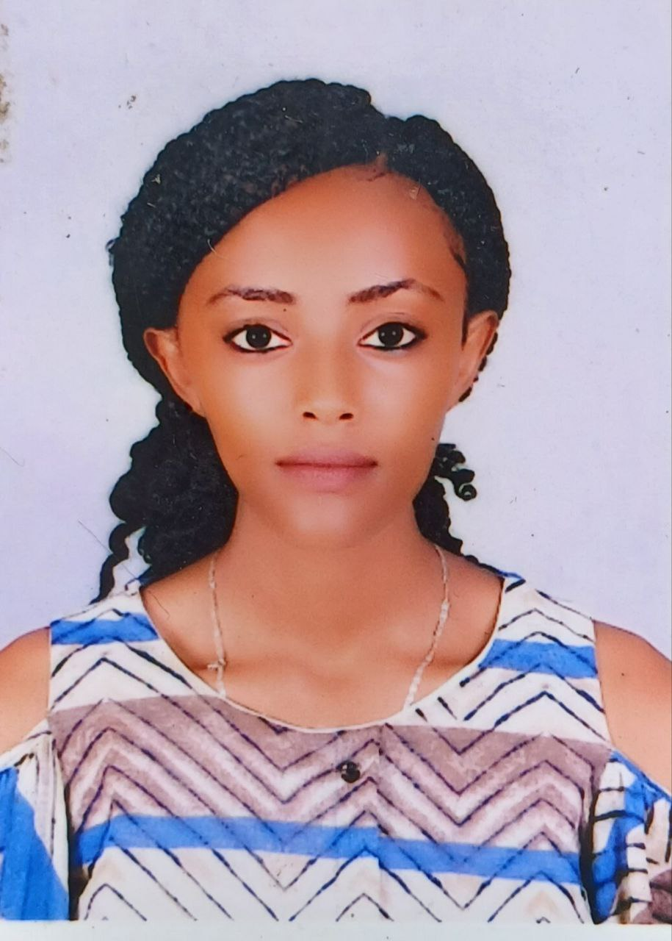 | P.O. box 395, Wollega University, Nekemte, Ethiopia
 | +251938856657
 | bontumamiru@gmail.com
 | Sex : Female/ Date of birth : 24/03/1998 / Nationality : Ethiopian

JOB APPLIED FOR  POSITION: | Freelancer (translator and survey worker)

Work Experience: Private sector worker and community service organizer
- Free service teacher at Bethel and kidane Mihiret School for two years, community service organizer till now
- Translation service with different agencies since 2021
EXPERIENCE AS  A TRANSLATOR: | I have more than 3 years of experience on translation with both local & international companies. I work on three languages, English, Amharic, and Oromo. I have good command of the three languages. For the last 3 years, I have been work with Babilos international group on Social posts project and many other projects. With them I have translated around 200, 000 words, both English to Amharic and English to Oromo. I also worked on reverse translation from Oromo and Amharic to English. I have also worked with other agencies like db intl group, transparent intl group, Somya intl group, Universal translation services, SMARTCAT, upwork, translation café and translationdictionary.com. In addition to translation, I also work on reviewing, proofreading, and subtitling activities. For this work, I can use different tools like, Dejavux, Grammarly, SDL Trados, IBM CAT tool, Memsource, MemoQ, smart cat, Mate Cat.

Mother Tongue(S): | Oromo and Amharic languages (bilingual)
Other language(s) | UNDERSTANDING |  | SPEAKING |  | WRITING
Other language(s) | Listening | Reading | Spoken interaction | Spoken production
English | Excellent | Excellent | Excellent | Excellent | Excellent
EDUCATIONAL & TRAINING:
Grade Attend | Name of school | Years of Study(GC) | Diploma Award
12+ 4 | Rift valley university | 2017-2020 | BA in Sociology
12+ 4 | Wollega University | 2022 -2025 | BA in special need  (Candidate)
E-learning | Arizona State University (online) | 2024 | Certificate

PERSONAL SKILLS:
Communication skills: Good communication skills gained through my experience as a
Surveyor presenter and community Service organizer
Job-related skills:
- Excellent ability to deliver the work efficiently, good ability to submit tasks on time
- Flexibility in solving problems during the work
- Excellent ability to communicate with concerned bodies about the status of the work
- Excellent ability to represent and stimulate interest among fellows and excellent ability to think creatively and propose alternative approaches.
- Excellent managing and team leading skills and excellent facilitating and team coordinating skill.
ADDITIONAL INFORMATION:
Certifications: Higher Diploma program, Basic computer skills, E-Learning

REFERENCES:
- Dr. Dagim Samuel Temesgen, Department head of Pharmacy , Wollega University, Nekemte, Ethiopia
E-mail: choosen2017@gmail.com
Mobile: +251-913127565
- Temesgen Dinsa Biyi (Msc), Department Head of Pharmaceutics and Pharmaceutical Supply Chain Management, Wollega University, Nekemte, Ethiopia
E-mail:tamidinsa@gmail.com
Mobile: +251964199288

