
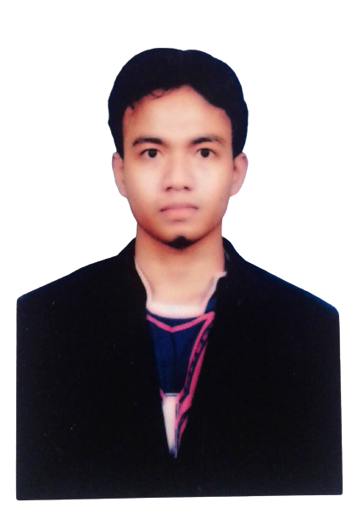
Mochamad Agung Kustrianto
Scan Whatsapp

aryogashuili@gmail.com • +6288238999789 • Instagram: @ashuili • Twitter: aryoga ashuili
Sido Akor 59, RT 9 RW 3, Desa Sembayat, Kec. Manyar, Kab Gresik, Jawa Timur
Blora, 24 November 1992 • 160 cm / 60 kg • Islam • Married

PROFILE
I am Mochamad Agung Kustrianto, graduated from Muhammadiyah Gresik University, Electrical Engineering Study Program. Discipline, honest and responsible work ethic is always my priority in completing every job. I have competence in Microsoft Office, Administration, Machinery, Adobe Photoshop, Team Management, Logic Gate, Micro Controller, Coding, Welding, Fabrication Machinery, Mathlab, Express PCB, Wiring HI & Low Voltage, Control Panel. I have some work experience and training. Able to work individually or in a team, have a passion for development, highly dedicated, highly motivated, adaptable, and interested in learning new things.

FORMAL EDUCATION
- University of Muhammadiyah Gresik  Study Program Technic Elektro 2,96/4.00  - National 1 Blora High School  Program Technic Audio Vidio | 2013-2020  2007-2010

SKILL
- Microsoft Word  - Microsoft Excel  - Microsoft PowerPoint  - Administration  - Engineering | - Adobe Photoshop  - Management Team  - Logic Gate  - Micro Controller  - Coding, Welding | - Fabrication Machinery  - Mathlab  - Express PCB  - Wiring HI & Low Voltage  - Control Panel

WORK EXPERIENCE
- PT Fertilizer Inti Technology  Electrician  - RS Fathma Medika  Electrician  - PT Karya Multi Guna  Operator & Maintenance Asphalt Mixing Plant | 2019-Present  2018-2019  2010-2016
TRAINING & SERTIFICATION
- TOEFL Course  Language Center University of Muhammadiyah Gresik | 2022

ADDITION
- Language: Java (Active), Indonesia (Active), English (Intermediate), and Japan (Pasive)
Soft Skill: Communicative, leadership, teamwork, collaborative, discipline, time management, fast learner, problem solving, critical thinking, responsibility, detail oriented, creative, and innovative.

