ORANGE CAMEROON | 2018 – 2019

Brand Ambassador, Yaounde

Duty :
      - Promotion of new products
      - Search new clients

UPWORK | 2020 – PRESENT

Freeelancer

Duty :
      - Translation
      - Transcription
      - Data Research
      - CV Edition and Creation

Help Services | 2020 – 2022

Prospector, Yaounde

Duty :
      - Expand the market by searching for new clients

PROFESSIONAL EXPERIENCE
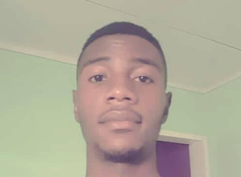

DIPLOMAS Y HOBBIES

Formaciones : Diplomados, Congresos, xxxxxxxxxx xxxxxx xxxxxxxxx xxxxxxxxxxxxxxxxx
Hobbies: xxxxxxxxxxxxxxxxxxxxxxxxxxxxxx


BOYOMO MBELLE ULRICH
QUALITIES

- Dynamic
- Team work
- Detail oriented
- Fast turnaround
- Consciousness
- Adabtability
- Fast learner

LANGUAGES

French : Native
English : Bilinguual




EDUCATIONAL BACKGROUND
2010-2015

G.C.E O level
Government Bilingual High School Yaounde

2015--2017

G.C.E A level

Government Bilingual High School Yaounde

2019-Present
Second Year

Univerty of Yaounde 2 Soa

- Translation
- Transcription
- Microsoft Word
- Microsoft Excel
- Pdf edition
- Format conversion

COMPETENCES
693009003

Ulrichboyomo@gmail.com

Yaounde, Cameroon

CONTACT
- Reading
- Travelling
- Basketball
- Music
HOBBIES
©AZURIUS – Modelos-de-curriculum.com

