

Resume - Ayanda Goboza

Contact information

Home Address: 92 Buffalo Road King Williams Town
Date of birth: 23 January 1987
Email: ayanda.goboza@gmail.com
Mobile: 0605295792
Other: 06556811567
Skype: live:.cid.4d7b795
LinkedIn: linkedin.com/in/ayanda-goboza-b78453a4
https://www.proz.com/profile/3264173

Profile
As a professional committed to delivering measurable results, I have honed my skills to effectively represent Client's needs and gathered data analytics for successful Customer Success representation. Along with my experience as a Freelance Linguist working with global agencies, I have been expanding my skills into other fields, specifically technical security, cloud computing, and data analytics. With an analytical and critical thinking mindset, I am confident in my ability to analyze complex data sets and identify key insights to drive business growth. Additionally, I have developed a strong Customer Success representation skill set, ensuring that I represent clients and understand their specific needs and desires to create a fruitful relationship. As someone who is results-focused, I have utilized my technical expertise to consistently ensure that customers are satisfied and renew their contracts. With my background in business administration and management, I am skilled in project management, allowing me to successfully lead projects from conception to completion. Outside of work, I enjoy reading about the latest trends in technology, particularly data analytics and Artificial Intelligence (AI). I am looking forward to connecting with talented recruiters who are looking for versatile professionals.

To whom it may concern.

RE Application for employment
I hereby forward my curriculum vitae.
Dear Hiring Manager,
I am writing to express my keen interest in the position at your esteemed company. As a highly motivated professional, I am excited about the opportunity to join your team and contribute my skills, knowledge, and expertise to help your company accomplish its goals.
As someone eager to learn and grow, I believe that this position will help me acquire new skills, improve my existing ones, and expand my knowledge of the translation industry. Working with professionals like yourself will help me achieve my career goals while contributing to the success of the company.
My extensive background experience in marketing, technical support, gaming, business, history, management, finances, editing legal documents, and translations. Film and TV Series titles, descriptions, cast/director, and other metadata will enable me to make an immediate contribution to your team. I take pride in my impeccable proofreading skills, extensive research, writing abilities, and translating expertise.
In addition to my existing skills, I have experience in HT, MTPE, XTM Cloud 13.0, Trados Studio, MemoQ, WordBee, Smartcat, Memsource, Smartling, and Wordfast. I am highly skilled in legal terminology, commercial and education areas, marketing processes of projects encompassing translation, proofreading skills, and self-editing before submission. A unique quality assurance process that is taken from industry best practices that helped me service a wide variety of clients.

I approach all work with a positive work ethic, efficiency, commitment, and integrity with attention to detail. I am excited about the possibility of becoming a valuable member of your team, learning more, and growing with your company.
Thank you for considering my application. I look forward to the opportunity to further discuss my qualifications and how I can contribute to your company's success.
Sincerely,
Ayanda

Educational Background

Qualification Matric - 2007 subjects- English, Afrikaans, History, Business economics, Travel and Tourism, Biology
Tertiary Qualification
Damelin College (SAIM) – Business Management 02/08-11/09
Certificate
Diploma Business Management 02/13-11/16 completed (NQF Level 6)
Business Management
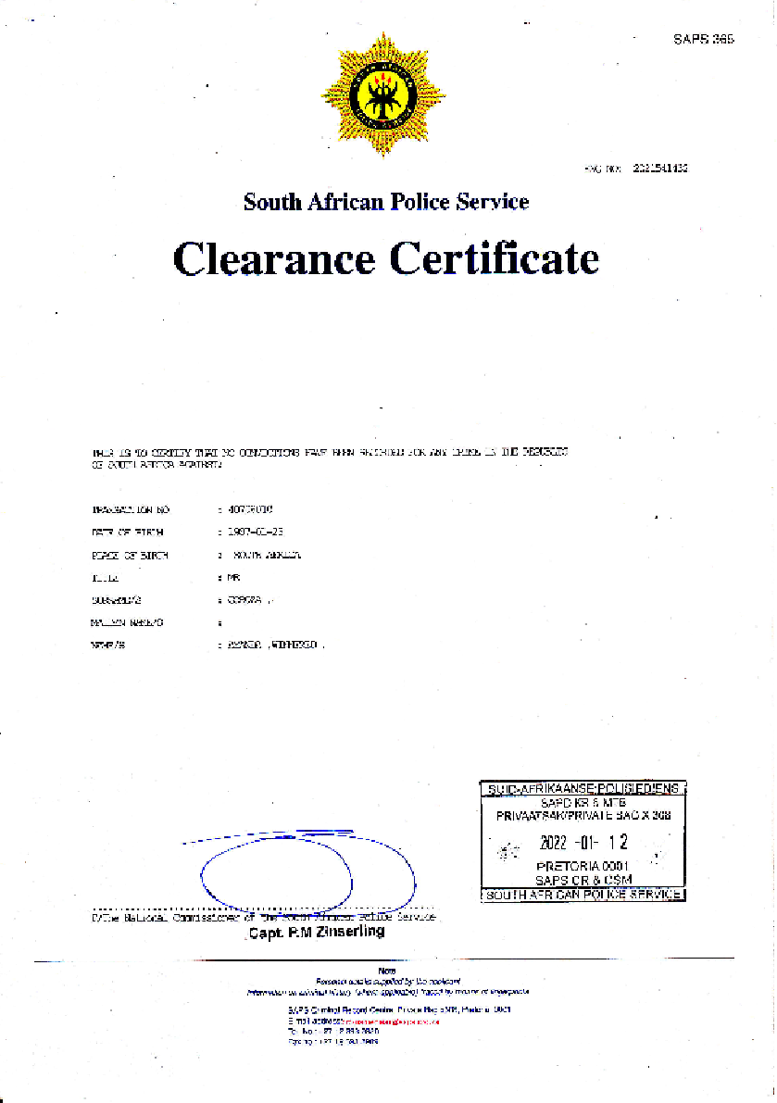
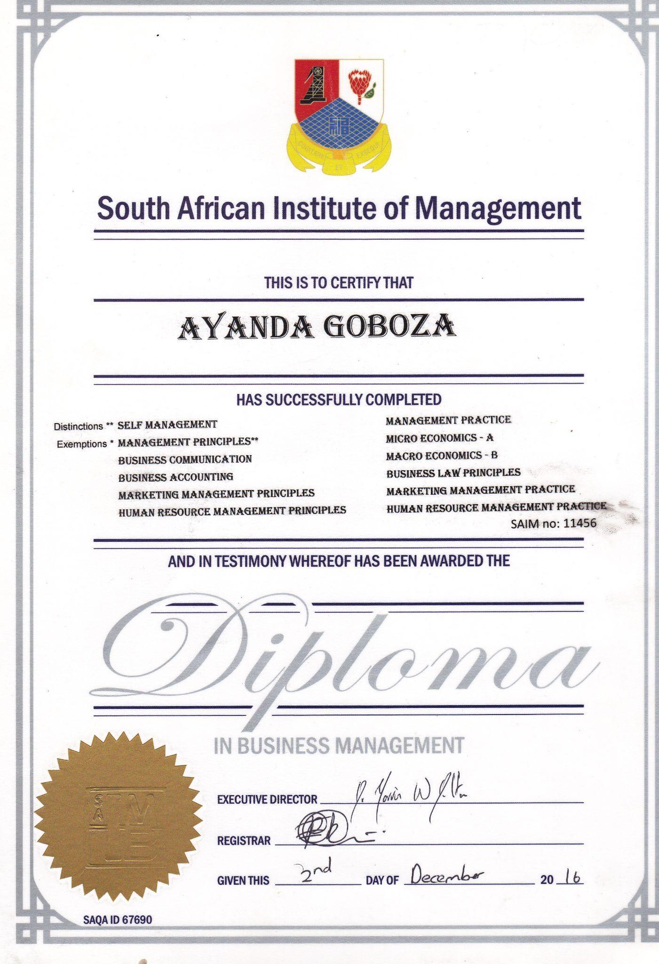
Working Experience

Department of Education
Job description - Examination Assistant 01/10-11
: Assisting with examination marking papers
Department of Cita
Job description – Data capturing and capturing 12/11-12/12
Roeseveld Quantity Surveyors
Job description- Field Administrator 02/13-12/14
Freelance Translator - Current 2016
Bilingoplus.com (Ukrainian Translation Provider)
Appen.com (China)
Transperfect (USA)
Languages
Native English
Afrikaans
Dutch
Spanish
German
Italian
References
Mr.E.J.Basson: Manager – Dep of Education NO: 0832859417
Mrs. F. Bikitsha Head of Depot Center NO: 0867598017
Mr. P. Vass: Quantity Surveyor NO: 0727805194
Dymtro Tarusin NO: +38 (066) 9557127
Beatrice Baglio: bbglio@transperfect.com

Achievements
The best turnaround time in my classes
Constant good rating scores on my Smartcat platform from clients.
Highest daily completion rate

Soft Skills
- Python (Programming Language), Business Analysis , Advertising Customer Relationship Management (CRM) Data Analysis CompTIA A +Training Course Certification Modernize, .NET Applications – Infrastructure as Code and CI/CD Data Management, Management Microsoft Office, Azure, Jira Qaility Assessment.
Knowledge of CAT tools
- MTPE, XTM Cloud 13.0, Trados Studio, MemoQ, WordBee, Smartcat, Memsource, Smartling, and Wordfast.
Hard Skills
- Strengthening writing with great communication abilities, Deep understanding of culture, Honing sound translation judgment, and acquiring advanced knowledge of language.

Typing skills
- View glossaries, consult reference materials, check previous translations, research internet sources, and write comments or post-edits.

Information processing skills and basic programming knowledge skills
- Very important especially for those who specialize in SEO Translation, IT, gaming, and other areas involving coding.

Project management knowledge skills
- coordination, teamwork, planning, and control techniques

Research skills
- The ability to identify the right sources, choose between them, and effectively use what I find out is crucial if I want to complete my projects.

Business Skills
- Commercial awareness - have a good and flexible understanding of how a business or industry works and what certain organizations want to achieve through products and services.
- Communication – l am we’ll speak in 3 official languages, write, pay extreme attention to detail, and listen to others' points of view.
- Teamwork- Can delegate and manage others by building good positive working relationships that help achieve goals and objectives.
- Negotiation and persuasion- I can express my way or views but at the same time be able to understand others where they come from so both parties can get what they want and be positive about it.
- Leadership- l can be a motivator to the people l work with and set examples meeting deadlines of tasks needed to be done.
- Ability to work under pressure- Can be calmly facing difficult situations but yet be punctual to stay on track and avoid stressing.
-Confidence - Maintain balance in the workplace and not to come across as arrogant but to have as much confidence in my colleagues and the company we work for.

Kindest Regards,
Ayanda Goboza

