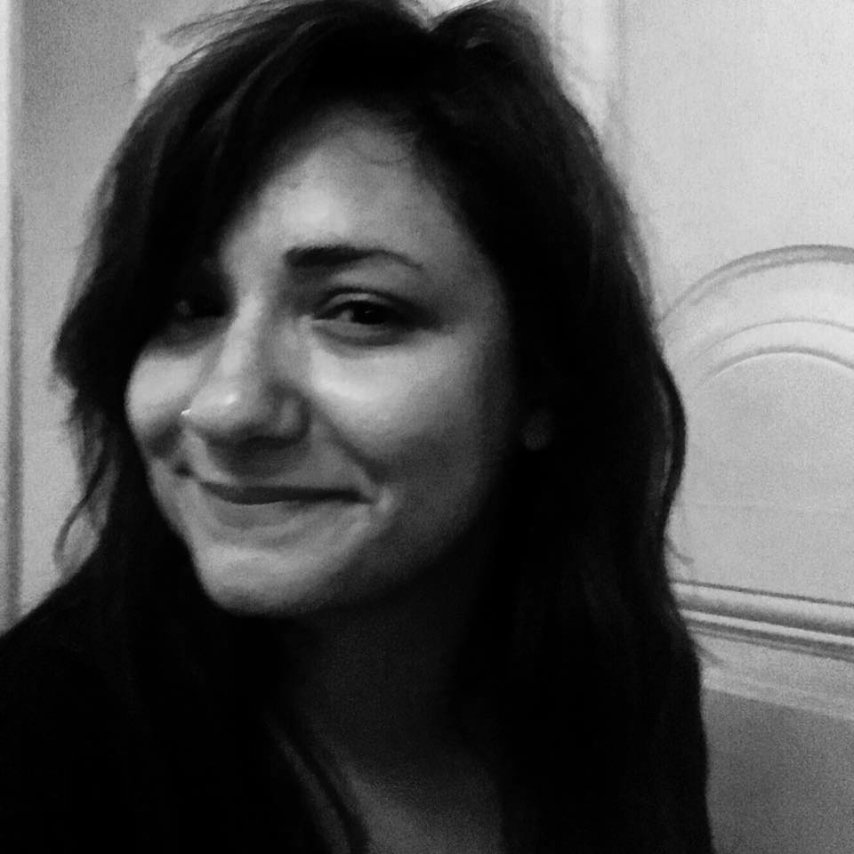

Irmak Eylül Ugurluoglu

Mahatma Gandi cad. 37/5

GOP/Ankara

TURKEY

Phone: 0535 255 94 33
E-mail: eylulerten@gmail.com

EDUCATION

2002–2008 Gazi University Faculty of Economics and Administrative Sciences Labor Economics and Industrial Relations
1999–2002 TED Ankara College Foundation High School
1991–1999 TED Ankara College Foundation Primary School
1989–1991 American Preschool Ankara

SKILLS
Foreign Languages English: Advanced
- Speaking, Writing, Reading: Advanced

French: Beginner
- Speaking, Writing, Reading: Beginner

Computer Skills MemoQ, SDL Trados, Translation Workspace, Lionbridge, Microsoft Office; Word, Excel, PowerPoint, Adobe Photoshop, SmartCAT, Monalle.

EXPERIENCES

2021-… WordKeepers Localization Game Reviewer
Reviewing and proofreading of localized games on PlayStation 4, Android, Microsoft Windows, iOS as well as the localization of games for game studios like MiHoYo and Netflix.

2021-… Hiventy Asia & Africa – Netflix Africa Subtitle Translator & Proofreading & Conformance

2020-… Alafranga Language Solutions, Disney+ Subtitle Translator

Pixelogic Media, Disney+ Subtitle Translator

2019… Bordo Translation Services Translator
Documents and grant agreements of European Union; United Nations manuals, handbooks; Civil Pages news; Topcon Triton, Voelker, US Department of State Federal Awards Agreements, academic papers on Civil Society Organisations, Civil Space etc.

2018-… e2f Translation Services Marketing Localization
Projects
Apple, Harley Davidson.

2018- … Sentro Language Services Contracted Translator
KIRA, Karcher, Garanti Leasing, Alkoçlar Raya Hotels, Akbank Art, Cepkask, Alarko Carrier, RixTrans.

Diltra Translations Contracted Translator
Hilton Double Tree, D Maris, Global Emerging Markets Group, D Resort Göcek, Seljel.

Viravira.co Web Blog Translation

March 2018 Saran Holding Web Site TR>ENG
Saran Digital Studios Dubbing Translator
(Discovery Channel)

December 2017 ES Language Solutions
Amazon, Regus, Google, Xerox, Samsung, SAI Global, Logitech.

2017-… NETFLIX Preferred Vendors Subtitle & QC Translator
Clients: ZOO Digital / Hiventy / Visual Data / Pixelogic Media / Deluxe Sfera
Creative Culture
Localization: Lipton
Power Translations
Legal Document Translations, Catalogues, Brochures.
Day Translations
Legal And Technical Translations
2016-… Book Translator for Several Publishing Houses ENG<>TR
2007-… Freelance Translator, English – Turkish / Turkish - English Translation, Localization, Transcription, Subtitling, Transcreation, Book Translator.
Excellent English speaking and writing skills. Translation of articles on entertainment, marketing, cultural, advertorial, educational, general, medical and technical areas. Translating TV shows, movies, books, TVCs, corporate films, advertising documentaries, and other audio and visual captions for the marketing industry. Operating computerized captioning system to provide subtitles. Localization of global brand strategies and advertising campaigns, products and web sites on various areas’ adverts. With the transcreation services I provide, I ensure your global brand campaigns remain consistent.

Brand the Bliss Advertising Agency Senior Copywriter
2015 - 2018
Creative ideas & copywriting all the printed and digital materials, transcreation and creation of creative campaigns for global brands like Shell, Schwarzkopf, Yeni Rakı, Mey Diageo, A.O. Smith, Smirnoff, Microsoft, Xbox.

Kuartet Advertising Agency Senior Copywriter
2014 –2015

dDf (dream Design Factory) and
iDf (International Design Fairs)
2012 –2014 Copywriter& Editor

Corporate printed/digital texts, translations, invitations, catalogues, booklets; editing, proofreading, event naming, concepting and slogans; writing of event materials.

The Adquarters Advertising Agency Copywriter & Editor
2013 – 2014 Managing creative processes of advertising campaigns, creative writing, TVCs scripts, print ads, writing every advertising material due to the campaign concepts, printed/digital texts, translations, invitations, catalogues, booklets, advertorials in both digital and conventional advertising principles; editing, proofreading, event naming, concepting and slogans
Mekanist Freelance English Writer, Editor - Turkcell IOS/Android App about Istanbul’s historic places.
December 2013

March 2012- December2013 Faros Hotel and Restaurants / Efes Sports Pub Advertising, Social Media and EventDirector, Copywriter

- In house advertising campaigns in both English and Turkish and directing all advertising processes of the hotels and restaurants.

October 2010- March 2012 İstanbul MESE PR Company, Editor, Writer

- Writing of press materials including corportae invitations, press releases, annual reports etc.
March 2010 - August 2010 Ankara Leo Organization and Communication, Editor, Social Media Expert, Writer
Ankara Leo Marketing, Durance, Editor
Ankara Leo Marketing, Web Editor
Aralık 2009 Leo Organization, Ankara Jazz Association, Translator, Editor

PERSONAL INFO

Nationality : T.C

Birth Place : Ankara, TURKEY

Birth Date : 01.11.1985

Marital Status : Married

