Kodzo Agbesi Gbenyanawo  Translator | kodzoale@gmail.com LOME, TOGO • +228 93880735

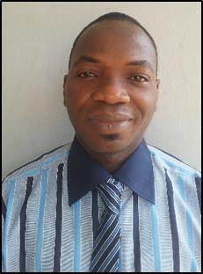
Dedicated and detail-oriented fresh-graduate professional with degree in Sociology of Education and Public Health.
Demonstrated success in formulating several documents, completing multiple projects, and developing diverse content. Proven ability in converting written material from one source language into the target language. Instrumental in developing content that accurately reflects company / client ideas while delivering excellent customer service. Possess exceptional communication skills in French, English, and Ewe language with an ability to establish rapport with individuals at all levels.

Areas of Expertise
- Proofreading  - Data Extraction  - Virtual Assistant  - Online Marketing | - Data Entry & Typing  - Creative & Technical Writing  - Strategic Planning & Execution  - Leadership & Team Coordination | - Internet research  - French Instructions  - Online French Teaching  - Advanced Microsoft Office Suite

Career Experience

Translator: Wagner International Consulting, NEW YORK, USA
Good Enterprise Limited, China
Hams Live Limited, India
Leverage expertise in performing as English to French translator, while ensuring precision and accuracy. Attend meetings to translate discussions and continually take language fluency assessments to certify fluency. Liaise with colleagues to ensure that translations are true to the original meaning.
TOOLS: SDL Trados, memoQ, Matecat
- Utilized exceptional expertise in proofreading French text and editing accordingly.

Sociologist, Studies Division of the Directorate of Drinking Water Supply (DAEP), LOME, TOGO 2015 – Present
Perform day-to-day duties, including answering emails, scheduling appointments, making phone calls, and writing administrative letter. Remain abreast of the latest research findings and formulate research projects that are novel and appropriate to context. Analyze data by using the appropriate techniques and coordinate social projects as well as develop survey questionnaires.
- Collected, formatted, and analyzed data using SPSS Statistics and calculation software.
- Designed and delivered educational and social documents to produce a positive tangible impact.

Education

Bachelor’s Degree in Sociology of Education and Public Health University of Lome, Lomé, Togo

