Mail Client Settings - M.S. Outlook 2010/2013/2016
Click File
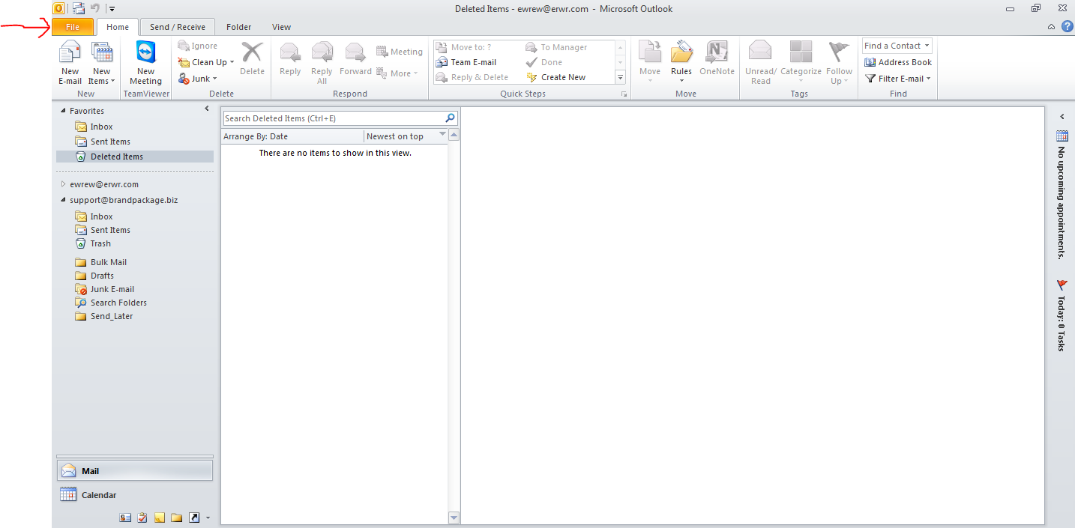

Click Add Account
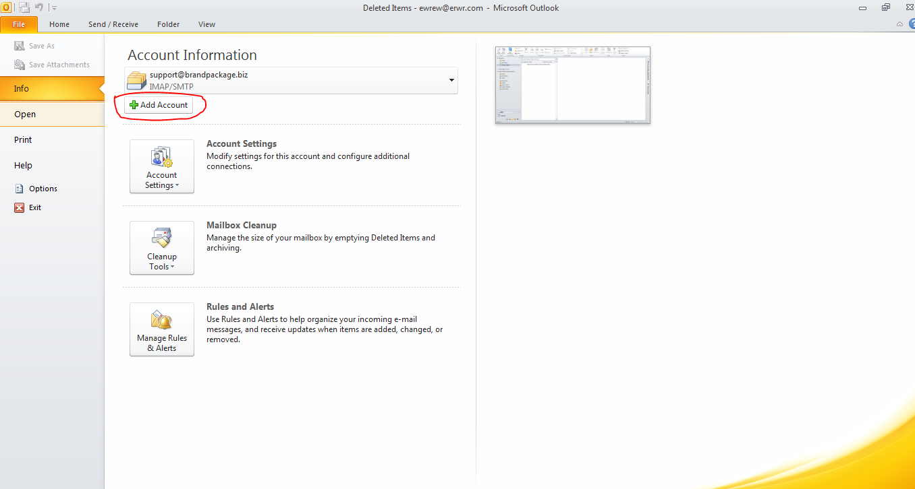

Click on Manual Configuration
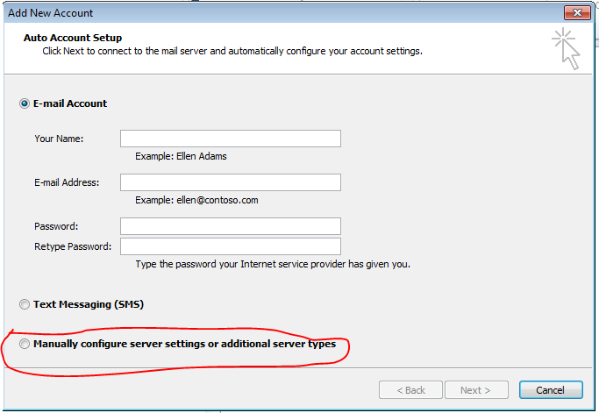

Click on Internet E-mail
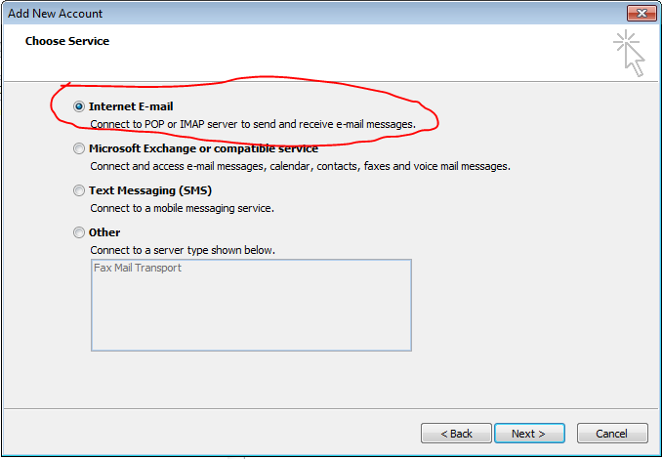

Fill the User Information
User Name: Name
Email Address: Email ID
Account Type: POP3
Incoming Mail Server: mail.domain.com
Outgoing Mail Server: mail.domain.com
User Name: Email ID
Password: Password

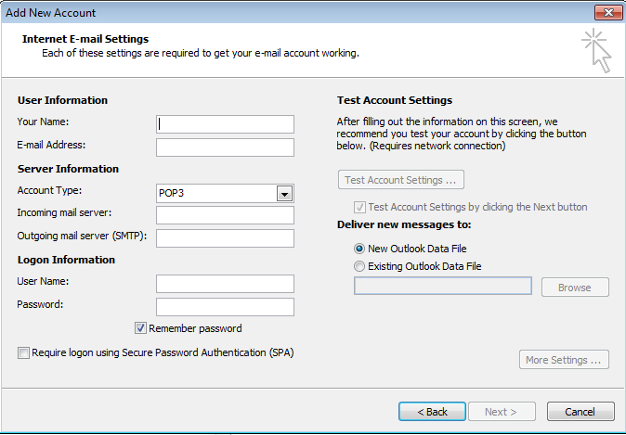

Click to More Settings
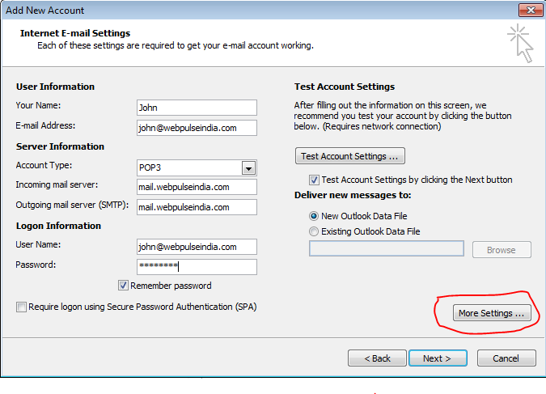
Select Outgoing Server Click Use Same Settings as my incoming mail server

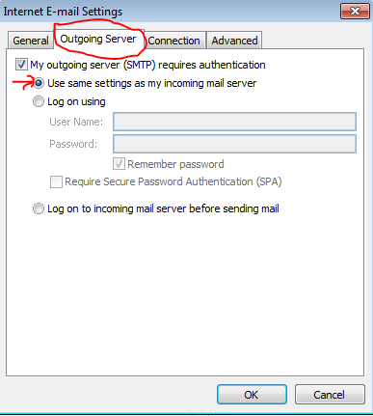

Select Advance
Incoming Server POP3 = 995
Outgoing Server SMTP=465

Then Click: OK

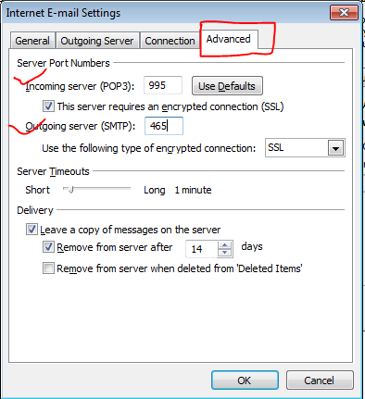

Click to Test Account SettingsSetup Completed

