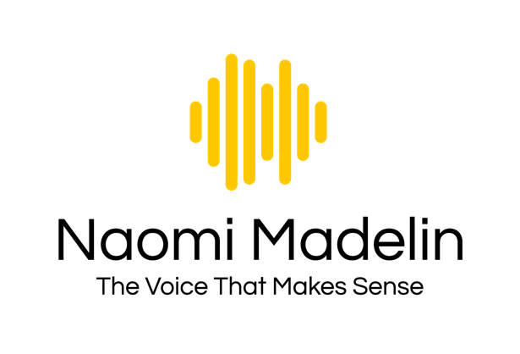 | voice@naomimadelin.com
 | +44 7780 177157
 | www.linkedin.com/in/naomimadelin/

www.naomimadelin.com

TRAINING / EDUCATION

BA(Hons) 2:1 Drama & Theatre

Courses at:
Central School of Speech and Drama, London
The Globe Theatre, London
Studio 111 Auckland, New Zealand
LAMDA Speech and Drama certificates

Vocal (singing) training with Sandra Scott in London
https://www.singinglessonsinlondon.com/
and with Frances Dickinson in Auckland
https://en.wikipedia.org/wiki/Frances_Dickinson_(musician)

Voice-over and Editing / Production training with Gravy For The Brain
https://www.gravyforthebrain.com/
EXPERIENCE

E-learning narration, first person narrative, Editing & Production
- Narration and first-person narrative voiceover
- Working remotely with other voice artists and pulling multiple audios together to create finished e-learning dialogue tracks
- Long-form course narration
- Editing and mastering to remove pops/clicks/breaths
- Splitting audio into multiple files for delivery

Corporate / Business Voiceover
- Narrating for corporate internal events videos and presentations
- Tutorial video voiceover
- Explainer video narration
- Usually includes full editing and mastering of audio
- Adding Royalty Free music / FX

Audiobook / Kids story narration / Production
- Specialising in character voices for a dramatic read
- 2022: Narrator and editor / producer of ‘Dunmoor’ by London Clarke, for Audible, to ACX standards

Character
- Creature / animal / kids / character voices for animation, improv, audio drama, games
- Narration for ‘sizzle real’ for 10-part mystical drama series
- Harry Potter Magical Movie Moments

SUMMARY  - Native English  - Natural contemporary RP accent  - Trained actor and voice artist  - Experienced businessperson with 25 years across multiple industries  - Seasoned entrepreneur  - Well-travelled  - French speaker (competent)  - Published writer (freelance journalist, professional business blogger and web copywriter)  - Passionate mountain trail runner | OTHER ACCENTS  North Yorkshire  Estuary  Scottish  West Country UK  Scouse  Russian  German  EU ‘other’ / ‘neutral’  French
HOME STUDIO

- Fully treated dedicated recording booth
- Sennheiser MK4 Condenser Microphone
- Focusrite Scarlett 2i2 Audio Interface
- Adobe Audition
- MacBook Pro

FULL CAREER

Following a business project management career in London, in the mid-noughties Naomi co-founded a grassroots business in the photography industry, that invented and sold photography products around the world, including in Apple stores.

Following entrepreneurship, Naomi worked as a consultant with smaller growing businesses helping with process efficiency, branding, business streamlining and marketing.

Having originally trained as an actor, in New Zealand Naomi worked as a screen actor in TV and film and on stage. She was also a freelance writer for magazines and newspapers.

Naomi has run her voiceover business since 2017. From her studio in France, Naomi works in many genres of voiceover, including:

- E-Learning, including character voices for dialogue
- Explainer and tutorial video voiceovers
- Corporate narration
- Medical & Financial
- Audiobook Narration
- Mini documentary narration
- Children’s stories and characters

Visit Naomi’s website / YouTube channel to hear samples and demos:

https://www.naomimadelin.com/

https://www.youtube.com/channel/UC9y2kjI4r_q-TYESJxBUZeA

