Aniket Dnyaneshwar Parate
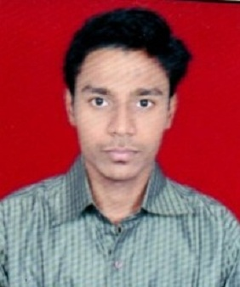
Mobile No. : 9096921962 / 8308605598
Email-Id. : aniketparate10@gmail.com
D.O.B. : 06th Oct, 1992
Nationality : Indian
Language : English, Marathi, Hindi
Address : Plot Number 13 A, Patel Nagar, Sai Nagar,
Badnera Road, Amravati – 444607 (Maharashtra).

OBJECTIVE:
I have good knowledge about Statistical methods and tools and outstanding knowledge about Microsoft Office (Word, Advanced Excel, Powerpoint) and Accounting.
I have good knowledge about Finance sector.
Looking for a challenging profile with my exposure to multiple skills where I can make difference to the organization.

EDUCATIONAL BACKGROUND:
- SSC from Maharashtra State Board, Pune (Maharashtra) in 2007.
- HSC from Maharashtra State Board, Pune (Maharashtra) in 2009.
- B.Sc. in Computer Science (Computer, Statistics, Electronics) from Sant Gadge baba Amravati university, Amravati in 2012.
- M.Sc. in Statistics from Sant Gadge baba Amravati university, Amravati in 2017.
- M.A. in Economics from Indira Gandhi National Open University in 2020.

SKILL SET & CERTIFICATIONS:
- MS-CIT
- Course on Computer Concept
- English Typing 30 WPM & 40 WPM
- Marathi Typing using English Language
- Microsoft Office (Word, Excel, Powerpoint)
- Certificate course in Advanced Excel
- Advance Diploma in Information Technology (ADIT)
- Base SAS 9.4 (Statistical Analysis System)
- Diploma in Professional Accounting Tally.ERP 9 With GST
EXPERIENCE:
I have 2 months experience as a Assistant Back Office in N & Y Company, Nagpur (Amravati Branch) from 16 Dec 2020 to 30 Jan 2021.
I have 2 months experience as a Disbursement Officer in Aavas Financiers Ltd. (Amravati Branch) from 26 July 2022 to 01 Oct 2022.
I have 18 months experience as a Statistical Assistant Professor in Bar. Ramrao Deshmukh Arts, Smt. Indiraji Kapadiya Commerce & Nyaymurti Krushnarao Deshmukh Science College, Badnera (Rly.) – Amravati (M.H.) from August 2022 to 12 Jan 2024.
I have 7 months working experience as a Insurance Advisor in SBI Life from 14 July 2023.
I have total 2 year 5 months experience.

COLLEGE PROJECT:
- Financial Express in Newspaper.

ACHIEVEMENTS:
- A State Level Event ‘GYAN-KSHITIJ 2012’ .
I secured 2nd rank in the event.

DECLARATION:
I hereby declare that the information furnished above is true to the best of my knowledge.
Place : Amravati

(Aniket D. Parate)
Signature
Date :

