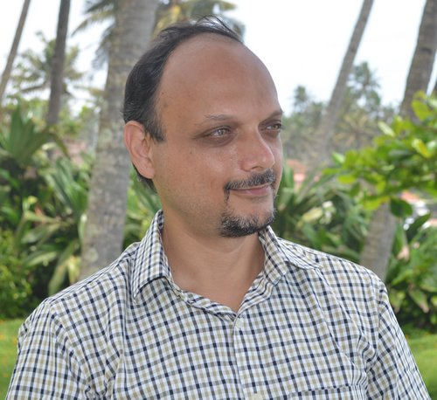 |  | Singh Girish Kumar  Male, 50 years old, born November 30, 1973  +91 (81378) 90613  girishsingh73@gmail.com - preferred method of communication  Resides: India  Citizenship: India, work permit available: India, Ukraine  Not ready to move, ready for occasional business trips
Desired position and salary
Speaker-translator
Specializations:
— Other

Employment: full time, part time, project work
Work schedule: shift schedule, flexible schedule, remote work
Desired travel time to work: does not matter
Work experience—15 years 9 months
October 2021 – present 2 years 8 months |  | International investment company SOLARGROUP  Financial sector  • Management, investment company (asset management)  Speaker - translator from/to Hindi  - Written/oral translation from/to Hindi. - Voice-over of videos from Russian into Hindi and vice versa. - Editing of the final video according to time codes.  Examples of work can be found on the channel: https://www.youtube.com/@user-rb8gl9bp5z
January 2018 – present 6 years 5 months |  | Freelance running your YouTube channel Family Thali  Video editor  - Shooting video clips; - Processing and editing of video clips; - Music editing and voice acting, audio overlay; - Design of intro and ending (intro/outro); - Overlay of text, screensavers, transitions; - Overlay of video and audio effects; - Video filling on YouTube; - Subtitling (SS) (Russian or English) - Creating a cover for the video.  Additionally: - Creating a title for the video; - Description of the video; - Creating key tags and hashtags; - Connecting monetization; - Installing cards inside the video; - Installing end-screens.  Examples of work: https://youtu.be/xhaen1TryPIhttps://youtu.be/aTtsN4P65yIhttps://youtu.be/yBWGly9ytbk  I work in programs: Wondershare Filmora 10, Kinemaster, Canva, PixelLab, Snapseed
January 2012 – present 12 years 5 months |  | Individual entrepreneurship / private practice / freelancing  Remote translator (Hindi, English, Russian)  Topics: general conversational topics, psychology, business, finance, law, technical, translations of videos for the YouTube channel. example: https://raduga-light.com/hi/
June 2020 – March 202110 months |  | Jooble, Kyiv  Kyiv  Information technology, system integration, Internet  • Internet company (search engines, payment systems, social networks, information, educational and entertainment resources, website promotion, etc.)  Outreach Linkbiler (Market: India, USA)  • Correspondence and establishing contacts with partners.  • Conduct of negotiations.  • Determination and selection of keywords according to the company’s activities for advertising.  • Exchange of links and advertising.  • Working with programs (Alexa, Ahrefs, Sequake)
September 2005 - December 20061 4 months |  | Eurokash Engineers Ltd., New Delhi, India (supply of power, electrical, mechanical and other equipment)  Marketing Manager, System Administrator, Translator  ● Searching for requirements/tenders for the purchase of power, electrical, mechanical and other equipment.  ● Interaction with the manufacturer (participation in negotiations, preparation of documentation for the manufacturer).  ● Interaction with the customer (determining order details).  ● Oral and written translation of tender documents from Hindi into Russian.
January 2002 - December 20032 |  | TOV "RELEEKSPORT", Ukraine  System administrator, web designer, translator  System administrator, web designer, translator
Education
Higher
2005 |  | National Technical University of Ukraine "Kiev Polytechnic Institute", Kyiv  Automation and computer-integrated technologies, Automated process control, master's degree
2002 |  | Microsoft Company  Microsoft Certified Professional
key skills
Knowledge of languages |  | Hindi- Native  English— C2 — Perfect  Russian— C1 — Advanced  Ukrainian— B1 — Medium
Skills |  | MS ExcelMS Word MS PowerPoint MS Outlook Adobe Photoshop PC User Internet MS Office English CSS MS SQL Server HTML Wondershare Filmora 10 Kinemaster Canva PixelLab Snapseed Hindi
Additional Information
About me |  | Creative, imaginative, attentive, committed.

